TRF Canada Announces Endowment for Mak Peace Center
#rotary #trfcanada #rotaryfoundation #peopleofaction #rotaryresponds #rotarypeace #positivepeace
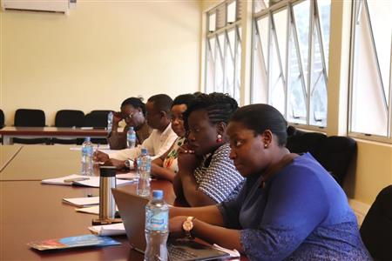
The Rotary Foundation Canada is pleased to announce that on behalf of Canadian Rotarians an endowment has been funded to support the annual capstone seminar at Rotary’s newest Peace Center at Makerere University in Kampala, Uganda.

The endowment was established with a gift of CAN$125,000.00 (US $100,000) to The Rotary Foundation. The seminar is an opportunity for peace fellows to reflect and report on their social change initiative efforts to an audience of peers, Rotarians, and experts in the field. The year long certificate courses at Makerere overlap allowing current and incoming fellows the opportunity to network and build fellowship.

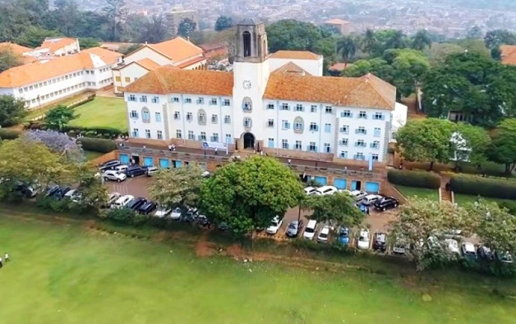 | 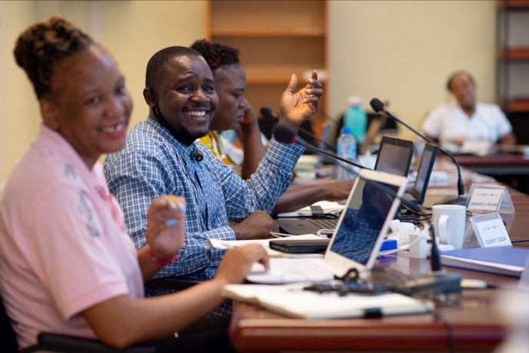
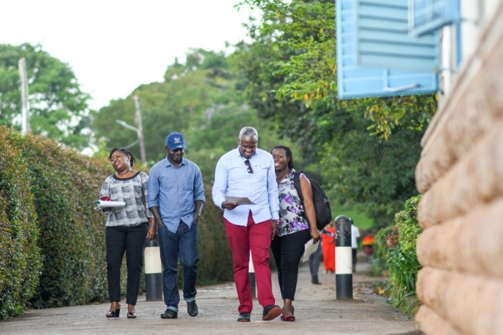 | 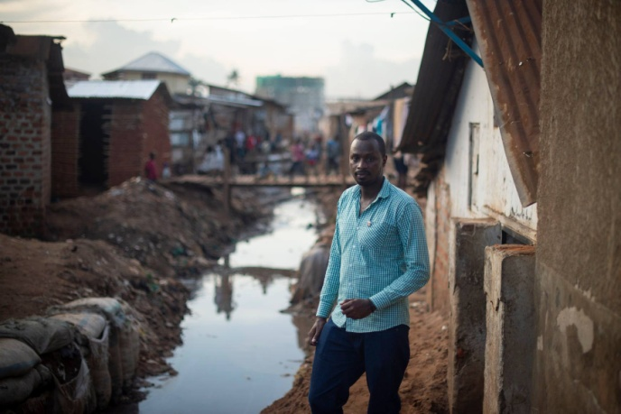

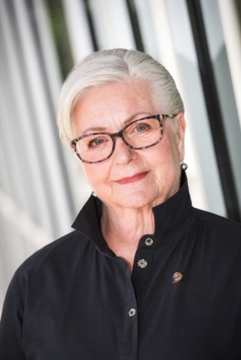
Chair TRF Canada
Dean Rohrs
Trustee Dean Rohrs the Chair of The Rotary Foundation Canada stated, “I recently, as President of the Rotary Foundation Canada, signed an Agreement to establish the ‘Canadian Rotarians Makerere Peace Endowment’. I do so on behalf of all Canadian Rotarians who continually demonstrate their commitment to peace in Africa. May this endowment be a constant reminder of the strong connections between Canadian Rotarians and Africa.”

The Canadian Rotarians Makerere Peace Endowment will give fellows the opportunity to present their research and the work they have done on their individual social change initiatives. The seminar will be attended by the larger university community and Rotary members from Uganda. The seminar will be shared across Africa and permit an expanded reach of the work being done at Makerere.

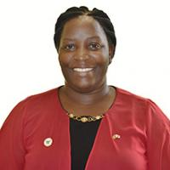
Peace Center Director
Helen Nambalirwa Nkabala
"The capstone seminar week is an opportunity for Rotary Peace Fellows at Makerere University to show how their social change initiatives have catalyzed change towards building peaceful communities in Africa and beyond,” says Makerere Peace Center Director Helen Nambalirwa Nkabala.“We are very grateful for the Rotarians in Canada who will be making this seminar possible.”

Best practice in leadership development shows that the most impactful learning happens when you convene a group of professionals after they have had experience applying new learning to their own circumstances. The seminar will include personal leadership, reflection and resiliency, relationship-building, and engagement opportunities with Rotarians and the alumni network.

The Rotary Foundation named endowments are established with a gift of US $25,000 or more. Rotarians or friends of Rotary may create a permanent legacy in their own name or in honor of a friend or family member. Rotary pools these gifts for investment purposes but maintains a separate accounting for each named endowed fund. Donors receive a personalized endowed fund certificate suitable for framing when their fund is established, as well as annual financial updates.

For further information on Rotary Peace Centers visit https://www.rotary.org/en/our-programs/peace-fellowships

Fact Sheet on Makerere Peace Center - https://my-cms.rotary.org/en/document/rotary-peace-center-makerere-university-fact-sheet

Rotary Named Endowments – www.Rotary.org/rotary-endowment

