Keynote Speaker and Discussant

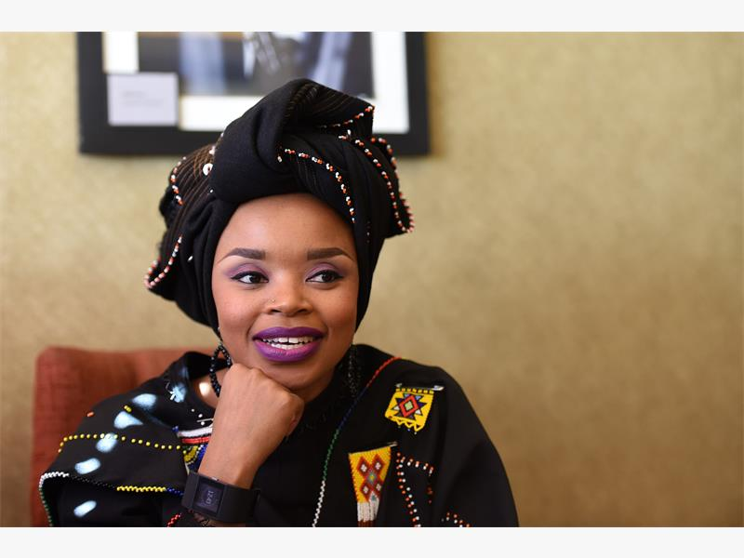Ms. Zoleka Mandela (born 1980) is a writer, activist, and Nelson and Winnie Mandela’s granddaughter. She has written about her addictions, her daughter's death, and her breast cancer.

In 2016, she was chosen as one of the BBCs "100 Women". She noted that her big regret was that she felt that she has only done worthwhile things since her grandfather's death. Mandela has campaigned against deaths caused by road accidents noting the particular hazards affecting sub Saharan African children who are twice as likely to be killed in car accidents as children anywhere else in the world.

Ms. Zoleka Mandela is fully committed to her role as a mother, breast cancer survivor and road safety activist; Zoleka Mandela’s life is a story she believes will change many lives. The unexpected and tragic loss of her 2 children surpassed her early breast cancer diagnosis catapulting her from a journey of pain and struggle to hope, faith and inspiration.

As a product of two legendary icons; former President of South Africa Nelson Mandela and freedom fighter, Nomzamo Winnie Madikizela-Mandela, Zoleka’s social responsibility is tremendously inspired by her grandparents and their passion to bring about change. In sharing her story, she hopes that her life will inspire people to follow many of their dreams despite life’s frequent ebbs and expected flows. Founder and Chairperson of the Zoleka Mandela Foundation, UN Road Safety Ambassador, BBC 100 Women and author of When hope Whispers.

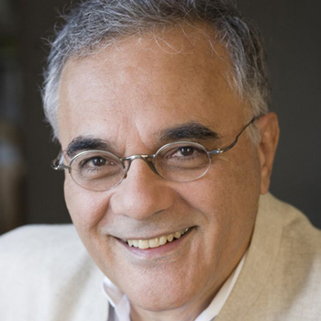Professor Mahmood Mamdani is from Kampala, Uganda and became director of MISR in 2010. He received his PhD in government from Harvard University. Mamdani is Herbert Lehman Professor of Government in the Department of Anthropology and Political Science and the School of International and Public Affairs at Columbia University, where he was also director of the Institute of African Studies from 1999 to 2004. He has taught at the University of Dar-es-Salaam (1973–79), Makerere University (1980–93), and University of Cape Town (1996–99) and was the founding director of Centre for Basic Research in Kampala, Uganda (1987–96). Mahmood Mamdani is the author of Good Muslim, Bad Muslim: America, the Cold War and the Origins of Terror (Pantheon 2004); When Victims Become Killers: Colonialism, Nativism and Genocide in Rwanda (Princeton 2001); Citizen and Subject: Contemporary Africa and the Legacy of Late Colonialism (Princeton 1996); and ten other books. Mahmood Mamdani was President of CODESRIA (Council for the Development of SocialResearch in Africa) from 1999 to 2002.

Panelists
Hon. Robert KyagulanyiSsentamua.k.a.Bobi Wine
Born12 February 1982 (age 35)Gomba District, he’s a resident of Magere, Wakiso District.

He holds a BA (Arts) Music Dance and Drama from Makerere University. His career starting in 2000 spans different fields, including music, film, entrepreneurship and philanthropy. An inspirational speaker, Wine started making music in the early 2000s. His first singles were Akagoma, Funtula, and Sunda (featuring Ziggy D), which brought him into the limelight.Wine has also starred in a number of movies, mainly starring in local movies commonly known as Binayuganda. In 2010, Bobi Wine was cast in Cleopatra Koheirwe's drama film Yogera and in a lead role in a Twaweza supported film Situkawith Hellen Lukoma in 2015.

A keen humanitarian activist who was appointed by both Twaweza and Action Aid as an ambassador, Bobbi joined active politics in April 2017 when he announced his candidacy for parliament in an upcoming by-election for the Kyaddondo East Constituency. His house to house walk campaign attracted a lot of attention both in Uganda and abroad. He won that contest by a wide margin, beating two seasoned candidates: SitendaSebalu of the ruling National Resistance Movement party and Apollo Kantinti of the main opposition Forum for Democratic Change.

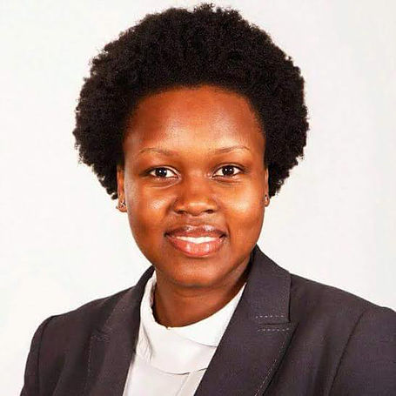Hon. Anna AdekeEbaju
Hon. Anna AdekeEbaju is the National Female Youth Member of Parliament representing all female youth in Uganda in the 10th Parliament. She was elected to this position as an Independent Candidate although she has held several leadership positions in the Forum for Democratic Change (FDC) party before being elected as a Member of Parliament. Adeke also serves as the shadow Minister of State for Children and Youth Affairs. At 25 years of age, Hon. Adeke is a holder of a bachelor’s degree in laws from Makerere University. She also served as a prefect in secondary school and later as the Guild President of Makerere University from 2013-2014. the fourth female to hold this prestigious position, during her reign, Adeke is remembered for her shrewd system of doing things with her name almost becoming synonymous to accountability.

She is very enthusiastic about the inclusion of female youth in decision making processes and seeing their participation in national development enhanced. She has made several proposals to government to ensure that the marginalization of female youth is dealt with by bridging the gaps that constrain them from participating in youth programming.
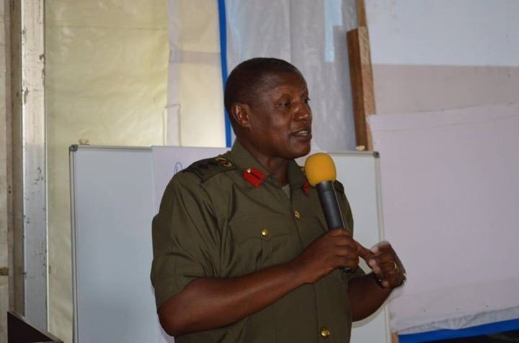Brigadier General Henry Masiko
Brigadier General Masiko joined the NRM in 1985 as a fighter and is currently the Chief Political Commissar, UPDF HQS/Ministry of Defence and Veteran Affairs. An Alumni of MakerereUniversity and Nairobi University, Brigadier Masiko holds a B.A. in Political Science and Public Administration, Makerere University and two Masters degrees in International Studies and Diplomacy from the University of Nairobi and Public Administration and Management from Makerere University. In addition to several Security andDefence, courses undertaken in China and France, Brigadier Masiko’searly work experience included positions in the Ministry of Planning and Economic Development, as a National Secretary for Social Sciences committee of the then National Research Council and the Department of Political Science & Public Administration Makerere UniversityAssistant Lecturer.

Since joining the National Resistance Army (NRA) in 1985, as a Freedom Fighter, Brigadier Masiko has held several appointments both in the Movement structures and the NRA/UPDF, includingNational Secretary for Youth Affairs – 1987-1991, Deputy Director for Political Education and Information 1991-1998, Deputy Director in the Office of the National Political Commissar, Movement Secretariat 1998-2001, Director, National Leadership Institute Kyankwanzi – 2001-2008 and Commissioner for Patriotic Clubs-Office of the President 2010-2017.

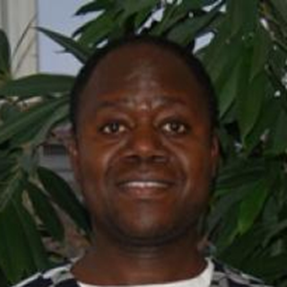Professor Julius Kiiza
Julius Kiiza is an Associate Professor of Political Economy and Development in the Department of Political Science and Public Administration at Makerere University (Uganda). He holds a Bachelor of Arts (Honours) degree from Makerere University, a First Class Master of Public Policy from the University of Sydney (Australia), and a PhD from the same University. Julius did his postdoctoral studies at Cambridge University Centre for African Studies in 2003. He has since been a visiting fellow at Dickinson College in Pennsylvania (USA), the University of Cambridge, UK; and the Washington-based Center for Global Development. Julius has an active research and publications interest in the broad areas of institutional political economy, local content and information disclosure in the oil sector (in Uganda/East Africa), economic nationalism, and transformative industrial policies. He was the lead editor of a book entitled: Electoral Democracy in Uganda: Understanding the Institutional Processes and Outcomes of the 2006 Elections (Fountain Publishers: Kampala). Julius also authored Chap 6 (Unlocking the Economic Potential of Northern Uganda) in UNDP’s award-winning Uganda Human Development Report 2015: Unlocking the Development Potential of Northern Uganda.

Programme Director and Moderator – Nelson Mandela Commemorative Lecture
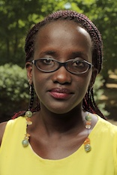Ms. Irene Ikomu
With a keen interest in policy, innovation and social impact, Irene Ikomu has built 8years of experience in the non-profit sector. She has specialist expertise in youth and inclusion and has actively advocated for youth inclusive policies within her work including contributing to the review of the Uganda National Youth Policy and the development of the African Union Youth Engagement Strategy. Irene is currently the Coordinator of the Civil Society Initiative (CSI); a collaborative program of the Aga Khan University and the Aga Khan Foundation to support civil society in East Africa based in Nairobi.

Before joining CSI, Irene co-founded two initiatives; the National Debate Council and Parliament Watch Uganda, which she managed for two and a half years. She has published and consulted for, among others, USAID, Open Society Initiative for East Africa, Society for International Development, and Well Spring Advisors. She has also served in an advisory capacity to USAID Uganda.

She was an inaugural recipient of the prestigious Young Female Lawyer of Year Award by the Uganda Law Society and has also been a recipient of the Mandela Washington fellowship and the Africa Open Government fellowship with the Open Knowledge Foundation.

Irene holds a Bachelor of Laws from Makerere University.

