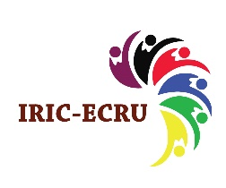
Research News: Mak RIF Supports creation of an interuniversity research and innovation community of early career researchers
The government of Uganda has, through the Makerere Research and Innovation Fund, supported creation of an inter-University Research and Innovation Community for the Early Career Researchers in Uganda (IRIC-ECRU). The 5-year project is run by investigators from Makerere University, Mbarara University of Science and Technology, Uganda Christian University and Mutesa I Royal University who received a seed fund from Mak RIF to start off the first year.
The project was designed to:
- Build researcher capacity of PhD students and ECRs
- Build a soft infrastructure for data & information management & sharing among the community members and beyond
- Enable technology empowered research outputs dissemination, and
- Facilitate researcher to society engagement and impact
The project is concluding its first year having had a number of local and international participants and facilitators taken part in a number of activities including research seminars, Co-Creation workshops, a public dialogue and research agendas evaluation as well as various discussion meetings on the feasibility and requirements for an interuniversity repository as a soft infrastructure for data & information management and sharing.
Notable among IRIC-ECRU outputs so far are interuniversity accountability/writing groups formed to accelerate completion of quality writing projects through peer support provided with experiences and resources from various institutions.
IRIC-ECRU has analysed the research agendas of individuals, partner institutions and the Uganda’s research focus to design the interuniversity community’s research agenda. This was done through a survey and a public dialogue. IRIC-ECRU focuses on researcher development to support the institutional and national research agendas in a complementary manner.
An interuniversity technical committee has also been formed to consider a roadmap of the phases of developing an inter-university repository, developing the architectural/structural design and policy development to guide the use of the infrastructure by partner institutions and others.
For greater impact, the second year of the project is being scaled up to involve more partners including government agencies and other higher institutions of learning.
Below are some of the comments from individuals who have directly participated in IRIC-ECRU activities;
“I appreciate IRIC l have gained mentors, improved my online presence, improved on my reading and writing.”
Participant on the Open Science for research Co-Creation workshop

“Thank you for allowing us to grow with you our mentor.”
PhD student

“Thank you so much IRIC. These initiatives will make our supervisory roles much easier.”
Senior academic/PhD students’’ supervisor

I registered a number of achievements from involvement in IRIC. These include completion of a manuscript, improvement of my PhD proposal, and gaining membership in a writing group”
PhD Student

For more information about this project and valuable resources, please visit http://nemraafrica.org/research-innovation-community

Some Pictures
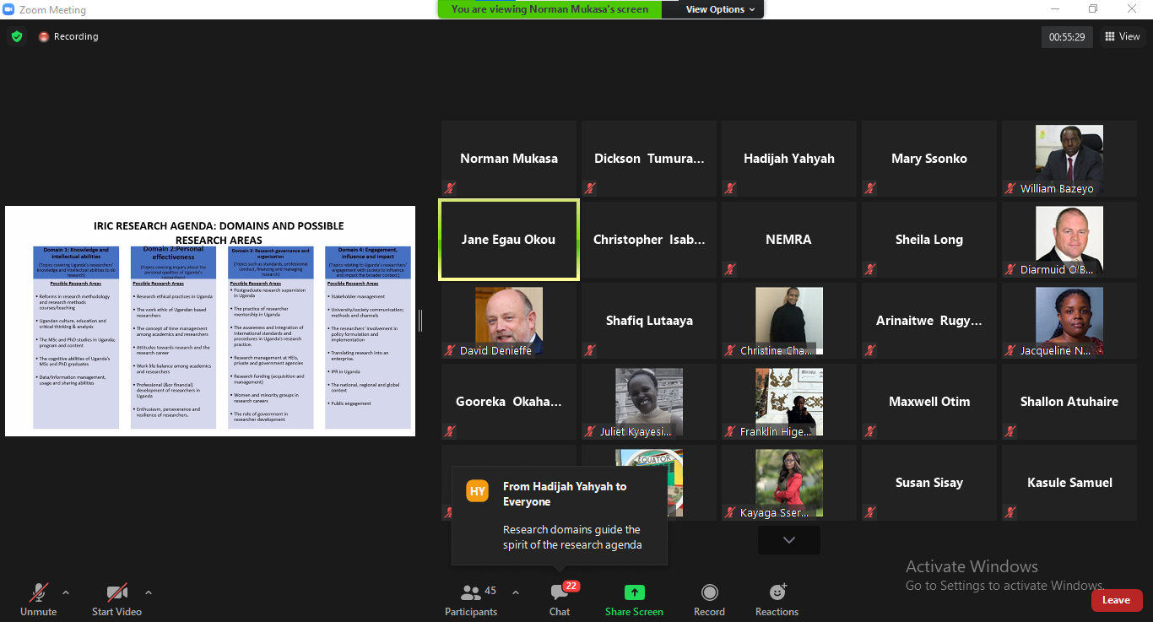
Figure 1Public dialogue to share the IRIC-ECRU Research Agenda to local and international stakeholders
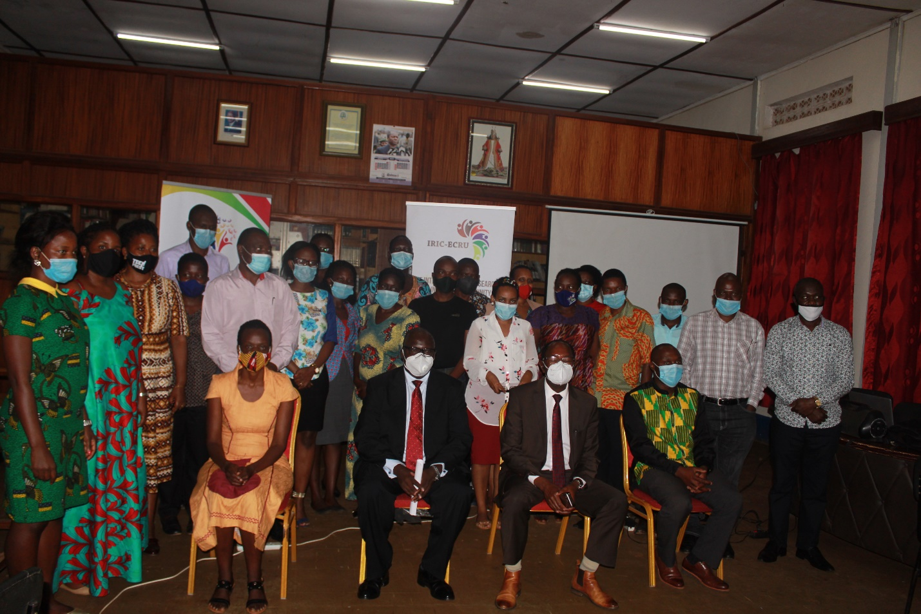
Figure 2 Closing ceremony of the first ever interuniversity Co-Creation workshop on academic writing held at Muteesa I Royal University. Seated and in black suit is Dr. Martin Ongol the Executive Secretary of the UNCST. Dr. Ongol was the Chief Guest

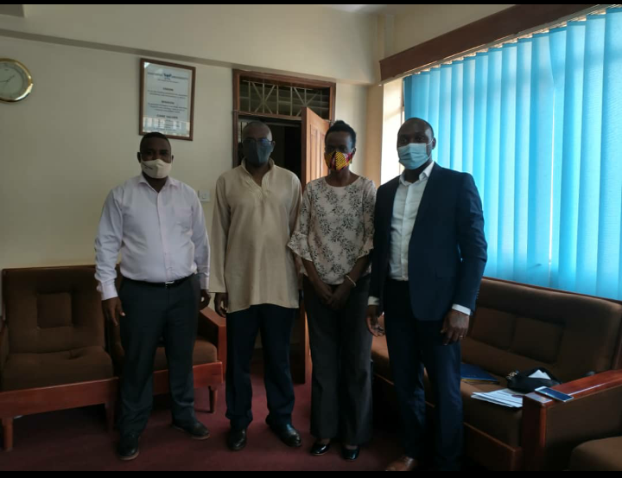
Figure 3 IRIC Team after with the Mak DRGT leadership during a discussion about Makerere University’s role in the research and innovation community.
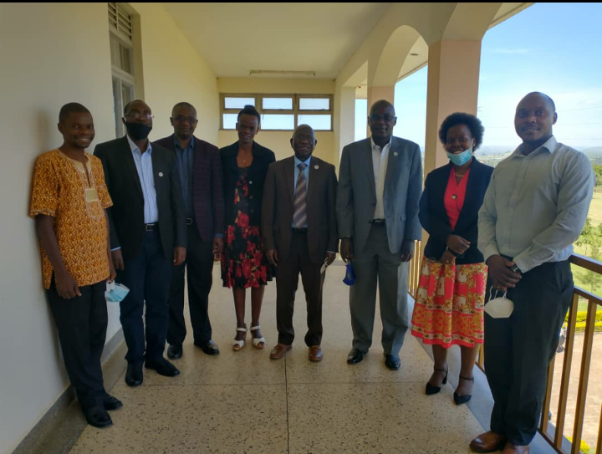
Figure 4 IRIC Team with the Vice Chancellor Mbarara University of Science and Technology

