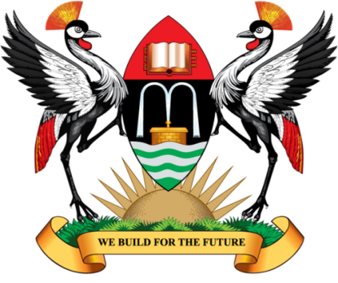

SPEECH BY THE VICE CHANCELLOR, PROFESSOR JOHN DDUMBA-SSENTAMU

AT THE POLITICAL SCIENCE REUNION

HELD ON THURSDAY, 25TH MAY, 2017 AT IN THE MAKERERE UNIVERSITY MAIN HALL

- The Guest of Honour, Prof. Apollo Robin Nsibambi
- The Vice Chancellor, Academic Affairs
- The Principal, College of Humanities & Social Sciences
- Deans and Directors
- The Head, Department of Political Science & Public Administration
- Distinguished Alumni of the Department of Political Science & Public Administration
- Ladies & gentlemen

……………………………………………………………………………………………..
It is my pleasure to welcome you back to Makerere University. Allow me to specifically welcome our Guest of Honour, and also one of the most influential and respectable academics of Makerere University, Prof. Apollo Robin Nsibambi. Prof. Nsibambi taught at this University during the 1960s and thereafter served as the Dean of the Faculty of Social Sciences from 1978 until 1983 and from 1985 until 1987. He was appointed Head of the Department of Political Science at Makerere University in 1987, a position he held until 1990. He served as the Director of the Makerere Institute of Social Research (MISR) from 1994 to 1996 and was the first non-Head-of-State Chancellor of Makerere University, a position he held from October 2003 to October 2007. We value his noble contribution to the development of the Department of Political Science and Public Administration, Makerere University and Uganda in general, and thank him for honouring our invitation to give a keynote address at this event.

Our distinguished guests, today is indeed a great day for the Department of Political Science and Public Administration when its alumni and well-wishers from all walks of life converge here to celebrate the achievements of the Department and deliberate on matters of national importance. Many alumni of the Department are instrumental in shaping the politics of this country and therefore a reunion of this kind is of great importance in furthering the contribution of the discipline of political science to national development. I salute all the alumni of the Department who are making significant contribution to the development of our country.
Ladies and Gentlemen, I take this opportunity to inform you that Makerere University holds dear its alumni and it is because of this that the University has a fully-fledged office under the Planning and Development Department that handles alumni relations. We greatly value you and believe that it is only through the good works of our alumni and your support that Makerere University can remain relevant and competitive in the global academic arena. I therefore call upon all alumni to support all initiatives aimed at improving Makerere University.

Currently the University is engaged in many initiatives aimed at improving the staff and students’ welfare and key among these is the Students’ Centre. The Students’ Centre is the inaugural project of the Makerere University Endowment Fund, an entity of the University established in 2014 and mandated to achieve her long term financial sustainability efforts. The Centre is expected to cost UGX15 billion and once completed, will enhance performance and the quality of life of students at this University. Any form of support towards this venture is welcome and much appreciated. At this juncture allow me to thank everyone who supported this cause by participating in the MAKRUN held on 14th May, 2017.

I once again thank the members of staff and students led by Dr Suzie Nansozi Muwanga for organizing this important event, the first of its kind in the Department. My sincere appreciation also goes to all those who have contributed to the successful preparations for this event.

I wish you successful deliberations and hope that by the end of the day, a new relationship between the Department and its alumni will be established to enable old and current students to continuously interact on developmental issues As we continue Building for the Future.

Prof. John Ddumba-Ssentamu, Vice Chancellor

